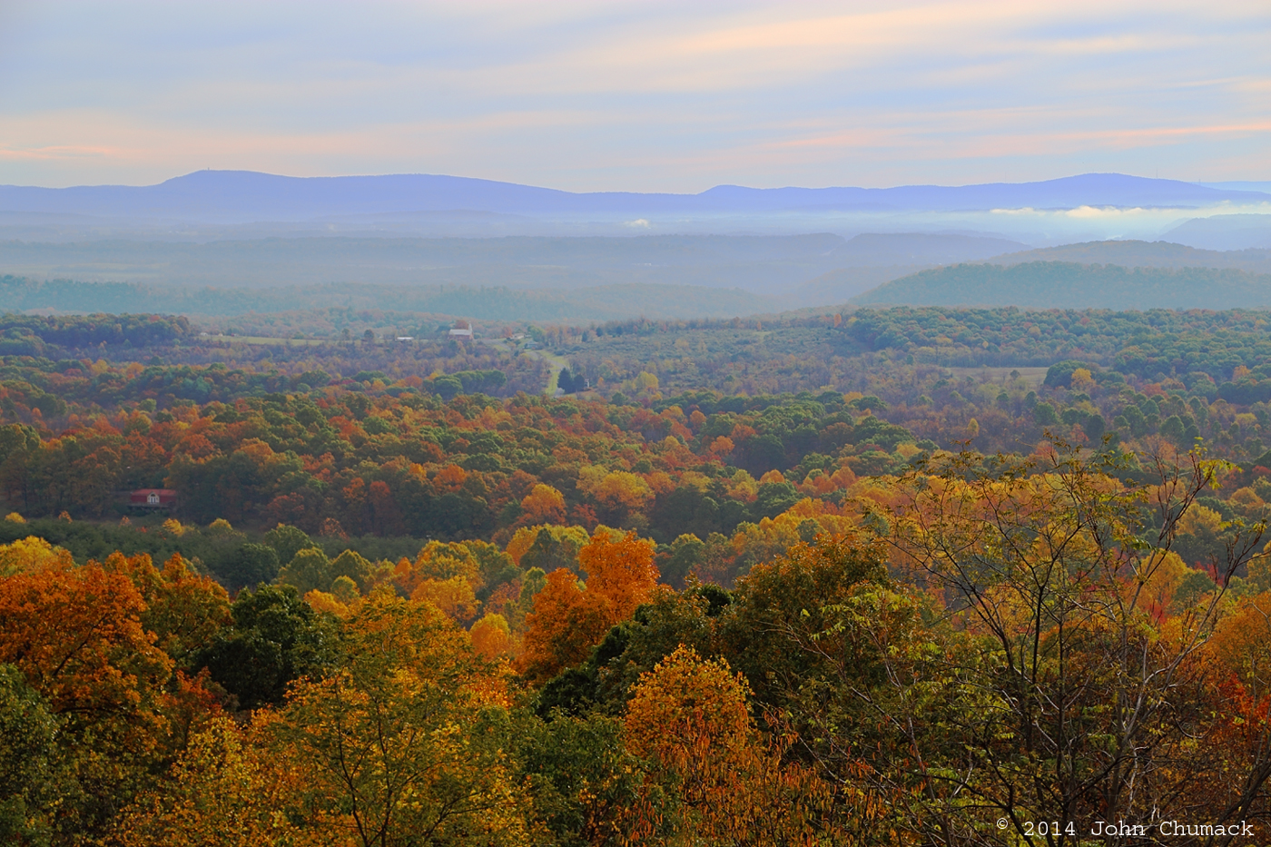

Society for Conservation Biology

Mountain Maryland Chapter

At Frostburg State University

New Logo Design Contest!!!

Enter to WIN!!!

Contact nthaydt@davidson.edu

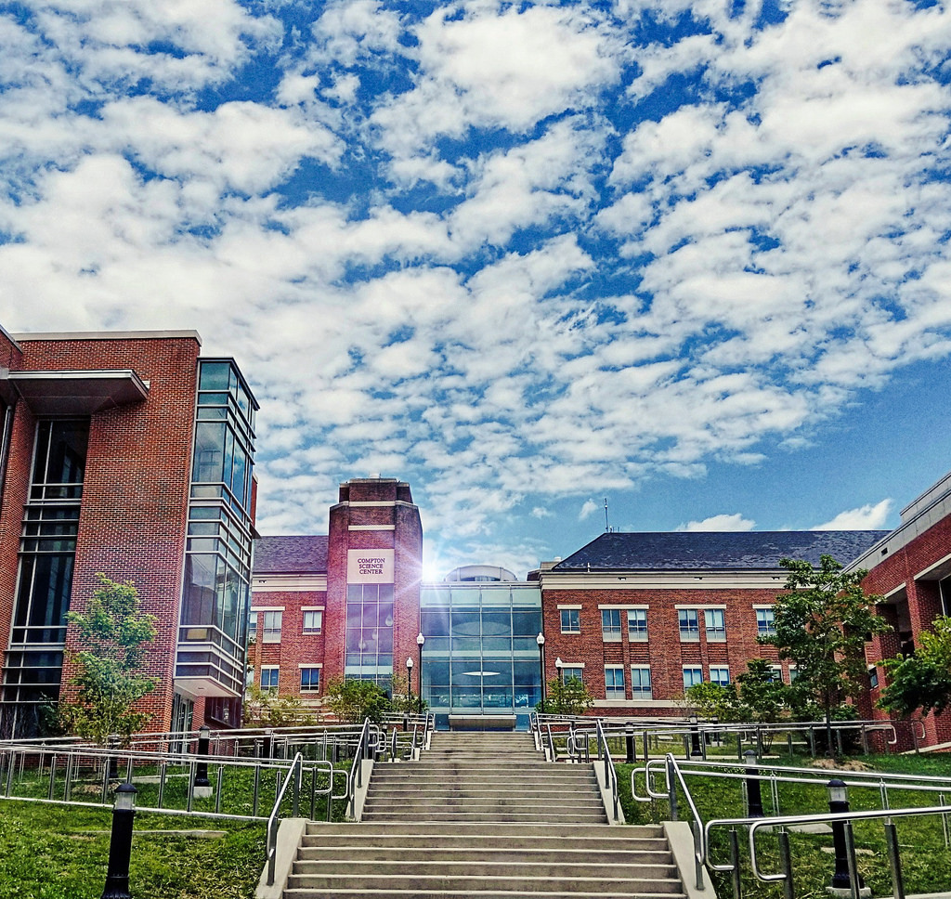

Social and Information Session

When: Monday, 19 November

6:30pm

Where: Natural History Museum, Compton Science Center

**Food and drink provided!**

Social

Information Session

Logo Vote

Raffle

